Autor’s full name

NAME OF SPEACH

Organization name

adress@domen.ru

Annotation of speech

Material (speech text) for publications should meet following requirements - comply with conference thematic and present personal input of authors.
Articles submitted by students and secondary school students (pupils) should contain name of scientific leader.

Article volume – 4-5 pages. Portrait orientation; paragraph indentation of 1 cm; Single line spacing; Editor - Microsoft Office Word; Font - Times New Roman. Page numbers are not set, the headers and footers are not used.

References in brackets: number in the reference list and the page number, for example, [1, 2] in order of appearance in the text. Footnotes are not allowed. References should be done according to the GOST R 7.0.5 2008 « Bibliographic reference » (including electronic resource references). References on text books are not welcome.

The formulas should be included in the text of the report with the built-in formula editor MICROSOFT WORD.

Pictures (photos) and tables should be inserted into the text, numbered and titled (table 1, pic.1).

Table 1.

Table in the text of article example
Size | … | … | …

10

You may use size 11 or 10 in the table if it is necessary.

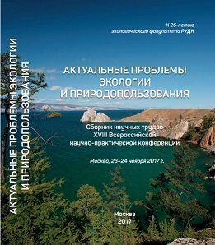

Pic. 1. Example of picture in the text of article

Inserting pictures, please bear in mind that paper version print out will be black and white.

References
- Author. Title. Date line.
- Автор. Article title. // name of periodical. Date line. – p. Number
- Name of electronic resource [Electronic resource]. Available at: http//… (access date)

